**Scott Bebington**

**U21546216**

**COS 210**

**Worksheet 5**

Question 1

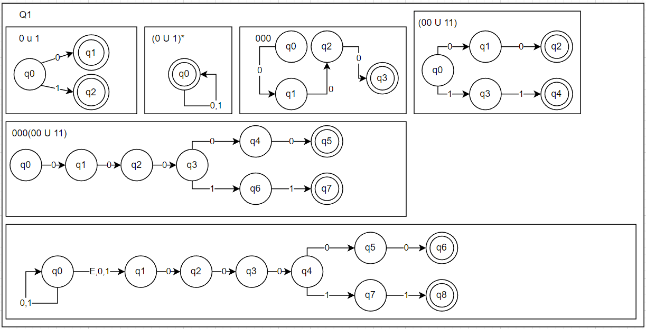

Question 2

We have the following functions

|  |  |  |
| --- | --- | --- |
|  | a | b |
| q0 | q0 | q0 |

And:

Lq0 = a.Lq0 U b.Lq0

This is equivalent to:

Lq0 = ( a U b ).Lq0

Using Lemma:

Lq0 = ( a U b )*

Question 3

Since the DFA does not accept any strings using the language {a,b}, the regular expression for this is the empty set.

L(M) = Ø

Question 4

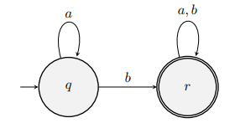

|  |  |  |
| --- | --- | --- |
|  | a | b |
| q | q | r |
| r | r | r |

And:

Lq = a.Lq U b.Lr

Lr = a.Lr U b.Lr

This is equivalent to:

Lr = ( a U b ).Lr

Using Lemma:

Lr = ( a U b )*

Substituting into Lq:

Lq = a.Lq U b( a U b )*

Using Lemma:

L(M) = a* b ( a U b )*